PCIT Space and Technology 101
Space Requirements and Room Set-up:
The conduct of PCIT requires a stripped therapy room serving as the playroom for the caregiver-child dyad (treatment room) and an adjoining observation room allowing the therapist to observe and coach the interaction through a one-way mirror. The treatment room is stripped so it can be a safe space for the child, even if he or she throws a temper tantrum. This means the room should only contain basic furniture (i.e., table and chairs). While it is recommended that PCIT toys are stored in the observation room or a separate space, if they are stored in the treatment room, they should be kept in a locked cabinet or chest. The therapist will place a few toy sets in the room before each session; children should not have access to all of the toys. The room should NOT house any computers, printers, or similar equipment. Decorations, such as wall hangings, plants, vases, lamps, etc., should be removed.

Traditional Room Set-up:
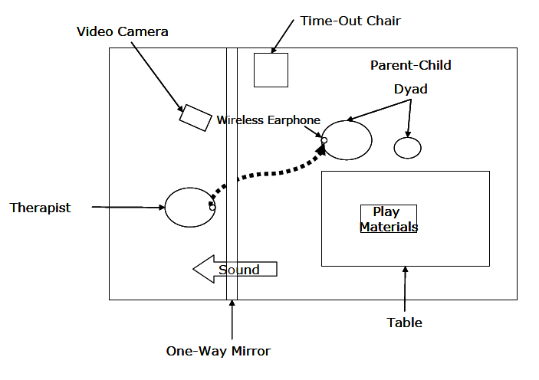
Traditionally, PCIT rooms have a one-way mirror adjoining the observation room and the treatment room (which includes a barrier room) on their shared wall. The treatment room should have an adult sized table with two chairs to accommodate a caregiver and child dyad, an adult sized sturdy time out chair and at least three choices of appropriate toys. Average sized treatment rooms are preferred rather than larger play or conference rooms. A sound system (microphone and amplifier) is necessary to hear the interaction between caregiver and child while you stand on the other side of the one-way mirror in the observation room, and a “hearing helper” system will be necessary for speaking to the caregiver through a microphone and earpiece device (bug-in-the-ear). A barrier room (or “time out” room) is ideally approximately 4x6 feet – no smaller than 4x4 feet and no larger than a small office – and it must have adequate light. When designing a barrier room consider having a “Dutch door” cut off approximately 5 feet high and/or a safety glass window into the timeout room to permit visual contact.

Time-out room

Alternative Room Set-ups:
- While a barrier room is preferred, it is not required. If your space or funding will not allow for the addition of a barrier room, your consultant will assist you in making necessary adjustments.
- If your space and/or funding will not allow for adjoining rooms with visibility into the treatment room, it is possible to observe and coach the caregiver-child dyad from a non-adjoining room. In this situation, the treatment room must have a video feed with a closed circuit monitoring system. With this set up, the observation room should still be in close proximity to the play room, to allow the therapist easy and quick access to the treatment room if necessary. Cameras should be mounted high on the wall or ceiling.
Equipment Requirements for PCIT:
The live coaching of caregiver-child interactions is a unique and defining feature of PCIT and comprises the majority of treatment sessions. The therapist must hear both the caregiver and child in the playroom and be able to talk to the caregiver from the observation room. Coaching occurs through an assistive listening device often referred to as “bug-in-the-ear” technology. The caregiver, in the treatment room, wears the receiving end of an audio transmission device, much like a hearing aid, while the therapist coaches through a microphone from the observation room. A variety of options exist to allow direct coaching and they range significantly in price. Most agencies also need to purchase audio equipment (i.e., ceiling microphone, amplifier, microphone, etc.) to allow the caregiver-child interactions to be heard, as well as to allow the therapist to coach the caregiver from the observation room. One example is shown below.
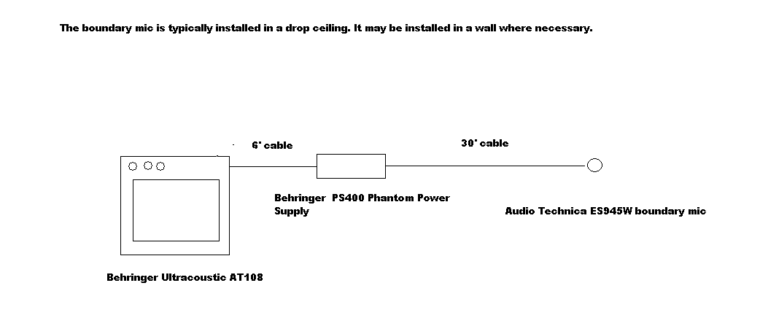
Note: The following is a list of optional PCIT equipment items collated by PCIT of the Carolinas as potential products used to create a system needed to conduct PCIT sessions. This is not an exhaustive list. Each component can be searched for additional options fitting your specific setting and desired price point. Additionally, high quality baby monitors (video and/or audio only) can be substituted for the omnidirectional microphone and speakers (including the phantom power supply and mic cables). PCIT of the Carolinas cannot guarantee the quality of each product or configuration.

Options for: Omnidirectional Condenser Boundary Microphones (Traditional Room Set-up; 1 needed per set-up)
Product Name | Website | Price
Shure MX393/O | https://www.amazon.com/Shure-MX393-Condenser-Microphone-Omni/dp/B0002JETTC | $242.00
Sennheiser e901 | http://www.sweetwater.com/store/detail/e901?adpos=1o1&creative=114579637681&device=c&matchtype=&network=g&gclid=CjwKEAjwqdi7BRCL6Zmjk5-rsTwSJABmrVabCThL3nn95xzZJw7N0v_J-ieWD9J2MfX_hX3GUp14uhoCfPrw_wcB | $239.95
Audio-Technica U851cW | http://www.fullcompass.com/product/318718.html?utm_source=googleps&utm_medium=shopping&utm_campaign=googleps&gclid=CJiru5vW5LoCFSNp7AodqhcA6g | $155.83
Audio-Technica PRO44 | http://www.sweetwater.com/store/detail/Pro44?adpos=1o2&creative=114579637681&device=c&matchtype=&network=g&gclid=CjwKEAjwqdi7BRCL6Zmjk5-rsTwSJABmrVabSkJzrcEoQZpysYBN0MhKdd2p7p8ZUVSktlcaRXeJtBoCpBnw_wcB | $99.00
Audio-Technica ATR4697 | http://www.bhphotovideo.com/c/product/664438-REG/Audio_Technica_ATR4697_ATR4697_Omnidirectional_Condenser_Boundary.html | $22.98

Options for: Speakers (Traditional Room Set-up; 1 needed per set-up)
Product Name | Website | Price
Genelec 8010 | http://www.sweetwater.com/store/detail/8010A | $295.00
Behringer Truth B3031A | https://www.amazon.com/Behringer-B3031A-BEHRINGER-TRUTH/dp/B001F1ZMHY | $249.00
JBL LSR305 Studio Monitor | https://www.amazon.com/JBL-LSR305-Studio-Monitor/dp/B00DUKP37C/ref=sr_1_12?ie=UTF8&qid=1467385739&sr=8-12&keywords=monitor+speaker | $141.66
Behringer Ultracoustic AT108 | https://www.amazon.com/BEHRINGER-ULTRACOUSTIC-AT108-Guitar-Amplifier/dp/B000MVYOZY | $99.99
Fender Frontman 10G 10W | http://www.fullcompass.com/prod/195028-Fender-Frontman-10G?utm_source=googleps&utm_medium=shopping&utm_campaign=googleps&st-t=googleshopping-musical_instruments&vt-k=&vt-mt=&vt-pti=195028&gclid=CjwKEAjwqdi7BRCL6Zmjk5-rsTwSJABmrVabVGgoxwBIbPoPNpnmM5IXi5LG3PtAF-NylN1K7PWufBoCgGLw_wcB | $59.99

Options for: Phantom Power Supply (Traditional Room Set-up; 1 needed per set-up)
Product Name | Website | Price
Audio-Technica AT8801 | http://www.fullcompass.com/prod/031395-Audio-Technica-AT8801 | $72.97
ART PHANTOM-1 | http://www.fullcompass.com/prod/134967-ART-PHANTOM-1 | $55.00
Behringer PS400 Phantom Power Supply | https://www.amazon.com/Behringer-PS400-BEHRINGER-MICROPOWER/dp/B000FG795I | $24.99
InnoGear 1- Channel 48V | https://www.amazon.com/InnoGear-Condenser-Microphone-Recording-Equipment/dp/B00KAPGLQC/ref=sr_1_1?s=musical-instruments&ie=UTF8&qid=1467403461&sr=1-1 | $19.99
Nady SMPS-1X | http://www.musiciansfriend.com/accessories/nady-smps-1x-phantom-power-supply | $19.99

Options for: Mic Cable (Traditional Room Set-up; 2 needed per set-up; size needed may vary depending on room size)
Product Name | Website | Price
Rapco Horizon (25’) | http://www.musiciansfriend.com/microphone-cables/rapco-horizon-microphone-cable | $29.99
GLS Audio (25’) | https://www.amazon.com/GLS-Audio-Cable-Patch-Cords/dp/B003JJQMD8/ref=sr_1_5?s=musical-instruments&ie=UTF8&qid=1467404997&sr=1-5 | $29.99
Monster Classic Mic Cable (10’, 20’, 30’) | http://www.sweetwater.com/store/detail/ClasM20?adpos=1o1&creative=114579639241&device=c&matchtype=&network=g&gclid=CjwKEAjwqdi7BRCL6Zmjk5-rsTwSJABmrVabumEFlB0L6yreUC929zKC667FltmX5birFeL65x7nRxoCFX3w_wcB | $24.95-$44.95
CBI MLC20 Low Z XLR (20’) | https://www.amazon.com/CBI-MLC20-Microphone-Cable-Foot/dp/B000VJJQUU/ref=sr_1_1?s=musical-instruments&ie=UTF8&qid=1467404997&sr=1-1 | $5.00
Musician's Gear Lo-Z (6’, 10’, 15’, 20’, 30’, 50’) | http://www.guitarcenter.com/Musicians-Gear/Lo-Z-Microphone-Cable.gc | $4.99-$16.99

Options for: Video and Audio Feed from the Treatment Room to the Viewing Room(s) (Alternative Room Set-up; 1 set/system needed per set-up)
*Please note: You will still need bug-in-ear and recording systems (in training only) for each setup.
Product Name | Website | Price
My D-Link | https://www.mydlink.com/content/productfamily | $70 - $300
Foscam Pan & Tilt IP Camera (FI8918W-B) | http://surusi.com/index.php?route=product/product&product_id=16562&gclid=CjwKEAjwu8m-BRDM8KTcjdj8qy0SJACdjSZp12WjLL-4oTsP60vVjRF7hkJJ89CwqJloZ0eQboDjExoCRRPw_wcB | $86.00
Linksys Wireless - N Internet Home Monitoring Camera WVC80N | http://www.neobits.com/belkin_linksys_wvc80n_np_linksys_wvc80n_network_p5781785.html?atc=gbp&gclid=CjwKEAjwu8m-BRDM8KTcjdj8qy0SJACdjSZpgSYRikLIhZkjnQvjK2VG5VpXEV_G1Bwa3wTbV8y7MxoCfCDw_wcB | $99.95

Options for: Bug-in-the-Ear Device (Traditional & Alternative Room Set-up; 1 set/system needed per set-up)
Product Name | Website | Price
- Williams Sound PFM PRO (battery powered)  - Williams Sound PFM PRO RCH (rechargeable - recommended) | - http://www.harriscomm.com/williams-sound-pfm-pro-personal-fm-listening-system.html  - https://www.amazon.com/Williams-Sound-PFM-PRO-RCH/dp/B00SLT7NCA | - $642.00  - $694.00
SENNHEISER EW112PG3A | http://www.altomusic.com/sennheiser-ew112pg3a-camera-mount-wireless-microphone-system-new-factory-repack | $449.99
Eartec 2 Simultalk 24G | http://www.bhphotovideo.com/bnh/controller/home?O=&sku=563169&gclid=CjwKEAjwqdi7BRCL6Zmjk5-rsTwSJABmrVabF3YsCRlB_PETGQs9U1RR0Slmmxn28Ijtd19487QNchoCmxLw_wcB&is=REG&ap=y&m=Y&c3api=1876%2C92051678882%2C&Q=&A=details | $289.99
Movo WMIC70 Wireless | https://www.amazon.com/Movo-WMIC70-Wireless-48-Channel-Microphone/dp/B0195EI8EQ?ie=UTF8&psc=1&redirect=true&ref_=oh_aui_detailpage_o00_s00 | $199.95
VTech DS6671-3 DECT 6.0 | https://www.amazon.com/VTech-DS6671-3-Expandable-Bluetooth-Answering/dp/B00CGYCOO8/ref=pd_sim_0_2?ie=UTF8&dpID=51PXU0Qz2hL&dpSrc=sims&preST=_AC_UL160_SR160%2C160_&psc=1&refRID=8RM7ABDNK0H31N6RDZKH | $74.95

Equipment Required for Training/Consultation:
Direct observation of therapy sessions is an important aspect of PCIT training. Therapists/agencies involved in the training process must therefore allow for the capacity to record therapy sessions, as a consultant will frequently be viewing sessions to assist in the training process. Videotaping sessions allows for session review by a consultant or supervisor, your review of caregiver skill level, and as a reference as the sessions progress. There are a couple of possible methods to record sessions: The video recording device can be a wall or ceiling mounted camera system that can capture or combine sound from both the treatment and observation rooms. Additionally, a traditional video camera mounted on a tripod in the observation room works well (placed here, it can record audio coming into the observation room and the therapists coaching). Trainees will be responsible for getting recordings to their consultant via uploading, or as necessary, by mail.

Options for: Recording sessions (for training only)
Options | Product | Website | Price
Video camera setup | Sony Handycam CX405 | http://www.bestbuy.com/site/sony-handycam-cx405-flash-memory-camcorder-black/2964179.p?id=1219563946200&skuId=2964179 | $229.99
 | Sony VCT-R100 (tripod) | https://www.amazon.com/Sony-VCT-R100-Lightweight-Compact-Tripod/dp/B000EFIJTA/192-5865055-2846646?ie=UTF8&redirect=true&ref_=oss_product | $33.00
 | PNY Elite 128GB MicroSDXC Card (with adapter) | https://www.amazon.com/gp/product/B01G26R7LA/ref=s9_newrz_hd_bw_b3I4RsJ_g147_i1?pf_rd_m=ATVPDKIKX0DER&pf_rd_s=merchandised-search-4&pf_rd_r=A5QFCCF2TSFG5EDE30S6&pf_rd_t=101&pf_rd_p=79181e65-0c09-51c3-a8ff-4454f707128f&pf_rd_i=3015433011 | $34.99
Computer software (to record from video camera or other video feed) | Camtasia Screen Recording and Video Editing Software | https://www.techsmith.com/camtasia-2gslp.html?gclid=CPLmz5Hu5LoCFUVp7AodOEkAXA | $299.00
 | NCH Video Capture Software | http://www.nchsoftware.com/capture/index.html | $60.00
 | VLC | http://www.videolan.org/index.html | Free

Options for: Video Storage
Product Name | Website | Price
Seagate 2TB External Hard Drive (other brands and sizes are options) | https://jet.com/product/detail/2f682546b1cf4d24a0fb31ed0e03f302?jcmp=pla:ggl:win_electronics_a1:electronics_accessories_computer_components_storage_devices_a1_top:na:PLA_348772260_24231328140_pla-156816956700:na:na:na:2&code=PLA15&ds_c=win_electronics_a1&ds_cid=&ds_ag=electronics_accessories_computer_components_storage_devices_a1_top&product_id=2f682546b1cf4d24a0fb31ed0e03f302&product_partition_id=156816956700&gclid=CjwKEAjwu8m-BRDM8KTcjdj8qy0SJACdjSZppfUlt13e1U9DHg-Y1ObE6z5fQcwyTTg6CG_DeCncZxoCVoTw_wcB&gclsrc=aw.ds | $89.99
ShareFile (online storage) | https://www.sharefile.com/ | $100/mo
IQ Storage (online storage) | http://www.iqstorage.com/ | $114/mo
Secure Server | In house secure servers are also an option, but prices and installation varies. | Variable

Additional Materials Necessary for PCIT:

PCIT Assessments:
PCIT is a highly assessment-driven intervention and requires the weekly administration of the Eyberg Child Behavior Inventory (ECBI). The ECBI may be purchased from Psychological Assessment Resources (PAR) at: http://www4.parinc.com/Products/Product.aspx?ProductID=ECBI ($45.00/pack of 25)

PCIT Toys:
Caregivers and children play together for the majority of PCIT sessions, and agencies conducting PCIT should be equipped with appropriate toys. The toys most appropriate for PCIT include unstructured and creative activities. PCIT discourages games with rules (i.e., board or card games), activities that encourage rough or aggressive play (i.e., action figures, toy guns, sports games) or toys that discourage direct caregiver-child interaction (i.e., puppets, books, video games). Plastic storage tubs or bags for each toy is helpful and convenient for easy clean-up and storage.

Recommended toy list:
- Large sets of construction toys (Duplo's, foam blocks, LEGO's, alphabet blocks, tinker toys, etc.)
- Fantasy play sets (farm scenes, airport, castle, zoo, etc.)
- Arts & Crafts (Play-Doh with tools, washable crayons and markers, coloring pages or paper, etc.)

Miscellaneous:
Other items necessary or helpful for conducting PCIT sessions are: a timer, alcohol wipes, PCIT protocol, forms for sessions, a clipboard, pens, and back-up batteries or chargers for equipment.

